Southern Alberta institute of Technology

Title: Backup & Recovery Strategies

By

**Femi Adams**

Winter 2023

**Travel Agency Backup Plan**

**Frequency of backups:**

* During normal business hours (9:00 am to 9:00 pm), incremental backups should be taken every 2 hours.
* During busy times (sales, pre-Christmas, post-Christmas, summer, fall, thanksgiving) incremental backups should be taken every hour.
* During slow times, incremental backups should be taken every 4 hours.
* A full backup should be taken weekly.

**Recommended backup method:**

* The recommended backup method is online backup using RMAN.
* The backup should include all tablespaces, including the additional tablespaces created for specific purposes.
* Backup sets should be split across multiple disks to minimize the risk of data loss.

**Recommendation concerning Archive/No archive mode with reasons:**

* Archivelog mode is recommended to ensure that all transactions are recoverable.
* The archive destination should be located on a separate disk from the database files to minimize the risk of data loss.
* Regular backups of the archive logs should be taken to ensure that the archive destination is also backed up.

**Recommendations concerning the number of redo log groups/members with reasons:**

* Two groups with two members each are recommended to ensure that there is always a current redo log available.
* The size of the redo logs should be increased to accommodate the average number of transactions per redo log.

**Strategy for effective use of a tape drive (or separate device/location):**

* The tape drive should be used to take a full backup once a week.
* The tapes should be rotated offsite on a regular basis to minimize the risk of data loss in the event of a disaster.

**Exact backup schedule:**

* Incremental backups every 2 hours during regular business hours.
* Incremental backups every hour during busy times.
* Incremental backups every 4 hours during slow times.
* Full backup once a week.
* Regular backups of the archive logs.
* The full backup should be taken to tape and rotated offsite on a regular basis.

**Testing backup plan (Cold Backup & RMAN)**

Simulated instance where users tablespace is deleted.

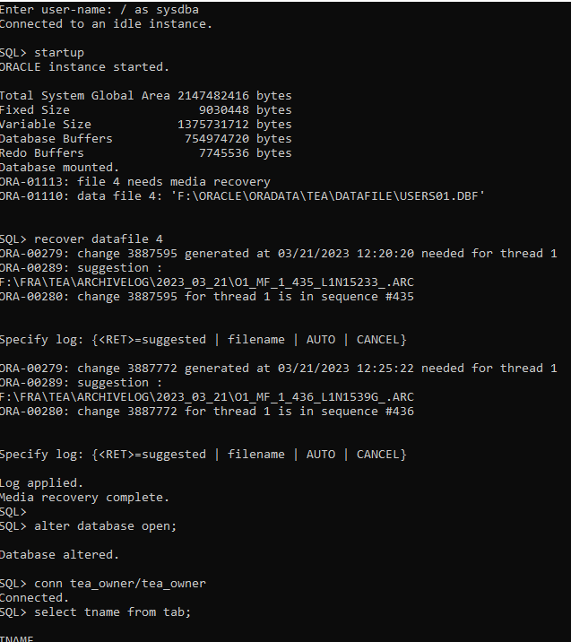

**RMAN Backup**

